Elton, Gruber, Brown and Goetzmann
Modern Portfolio Theory and Investment Analysis, 9th Edition
Solutions to Text Problems: Chapter 4

Chapter 4: Problem 1

A. Expected return is the sum of each outcome times its associated probability.

Expected return of Asset 1 = 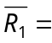16% × 0.25 + 12% × 0.5 + 8% × 0.25 = 12%
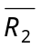 = 6%; 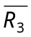 = 14%; 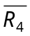 = 12%

Standard deviation of return is the square root of the sum of the squares of each outcome minus the mean times the associated probability.

Standard deviation of Asset 1 =
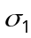 = [(16% − 12%)² × 0.25 + (12% − 12%)² × 0.5 + (8% − 12%)² × 0.25]^{1/2} = 8^{1/2}
= 2.83%

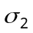= 2^{1/2} = 1.41%; 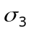= 18^{1/2} = 4.24%; 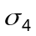= 10.7^{1/2} = 3.27%

B. Covariance of return between Assets 1 and 2 = 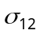=
(16 − 12) × (4 − 6) × 0.25 + (12 − 12) × (6 − 6) × 0.5 + (8 − 12) × (8 − 6) × 0.25
= − 4

The variance/covariance matrix for all pairs of assets is:

 |  | 1 | 2 | 3 | 4
 | 1 | 8 | − 4 | 12 | 0
 | 2 | − 4 | 2 | − 6 | 0
 | 3 | 12 | − 6 | 18 | 0
 | 4 | 0 | 0 | 0 | 10.7

Correlation of return between Assets 1 and 2 = 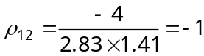.

The correlation matrix for all pairs of assets is:

 |  | 1 | 2 | 3 | 4
 | 1 | 1 | − 1 | 1 | 0
 | 2 | − 1 | 1 | − 1 | 0
 | 3 | 1 | − 1 | 1 | 0
 | 4 | 0 | 0 | 0 | 1

C. Portfolio Expected Return

A 1/2 × 12% + 1/2 × 6% = 9%

B 13%

C 12%

D 10%

E 13%

F 1/3 × 12% + 1/3 × 6% + 1/3 × 14% = 10.67%

G 10.67%

H 12.67%

I 1/4 × 12% + 1/4 × 6% + 1/4 × 14% + 1/4 × 12% = 11%

Portfolio Variance

A (1/2)² × 8 + (1/2)² × 2 + 2 × 1/2 × 1/2 × (− 4) = 0.5

B 12.5

C 4.6

D 2

E 7

F (1/3)² × 8 + (1/3)² × 2 + (1/3)² × 18 + 2 × 1/3 × 1/3 × (− 4)
+ 2 × 1/3 × 1/3 × 12 + 2 × 1/3 × 1/3 × (− 6) = 3.6

G 2

H 6.7

I (1/4)² × 8 + (1/4)² × 2 + (1/4)² × 18 + (1/4)² × 10.7
+ 2 × 1/4 × 1/4 × (− 4) + 2 × 1/4 × 1/4 × 12 + 2 × 1/4
× 1/4 × 0 + 2 × 1/4 × 1/4 × (− 6) + 2 × 1/4 × 1/4 × 0 + 2 × 1/4 × 1/4 × 0 = 2.7

Chapter 4: Problem 2

A. Monthly Returns

Month
Security 1 2 3 4 5 6

A 3.7% 0.4% -6.5% 1.4% 6.2% 2.1%

B 10.5% 0.5% 3.7% 1.0% 3.4% -1.4%

C 1.4% 14.9% -1.4% 10.8% 4.9% 16.9%

B. Sample Average (Mean) Monthly Returns

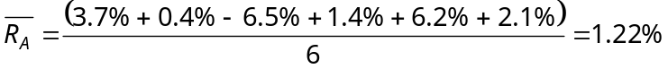

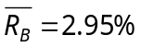

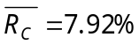

C. Sample Standard Deviations of Monthly Returns

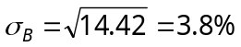

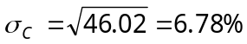

D. Sample Covariances and Correlation Coefficients of Monthly Returns

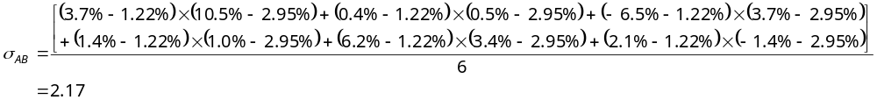 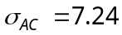; 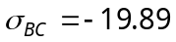

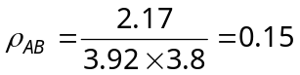

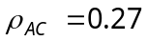; 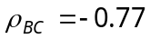

E. Portfolio Returns and Standard Deviations

Portfolio 1 (X₁ = 1/2; X₂= 1/2; X₃= 0):

Portfolio 2 (X₁ = 1/2; X₂= 0; X₃= 1/2):

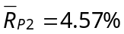

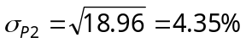

Portfolio 3 (X₁ = 0; X₂= 1/2; X₃= 1/2):

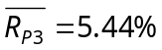

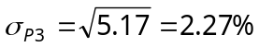

Portfolio 4 (X₁ = 1/3; X₂= 1/3; X₃= 1/3):

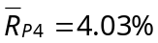
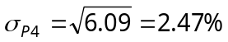

Chapter 4: Problem 3

It is shown in the text below Table 4.8 that a formula for the variance of an equally weighted portfolio (where X_{i} = 1/N for i = 1, …, N securities) is

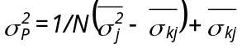

where 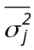 is the average variance across all securities, 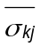 is the average covariance across all pairs of securities, and N is the number of securities. Using the above formula with = 50 and = 10 we have:

Portfolio Size (N) 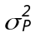

5 18

10 14

20 12

50 10.8

100 10.4

Chapter 4: Problem 4

As is shown in the text, as the number of securities (N) approaches infinity, an equally weighted portfolio’s variance (total risk) approaches a minimum equal to the average covariance of the pairs of securities in the portfolio, which in Problem 3 is given as 10. Therefore, 10% above the minimum risk level would result in the portfolio’s variance being equal to 11. Setting the formula shown in the above answer to Problem 3 equal to 11 and using = 50 and = 10 we have:

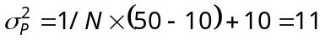

Solving the above equation for N gives N = 40 securities.

Chapter 4: Problem 5

As shown in the text, if the portfolio contains only one security, then the portfolio’s average variance is equal to the average variance across all securities, . If instead an equally weighted portfolio contains a very large number of securities, then its variance will be approximately equal to the average covariance of the pairs of securities in the portfolio, . Therefore, the fraction of risk that of an individual security that can be eliminated by holding a large portfolio is expressed by the following ratio:

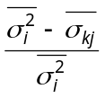

From Table 4.9, the above ratio is equal to 0.6 (60%) for Italian securities and 0.8 (80%) for Belgian securities. Setting the above ratio equal to those values and solving for gives 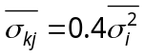 for Italian securities and 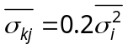 for Belgian securities.

Thus, the ratio 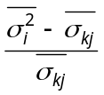 equals 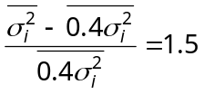 for Italian securities and 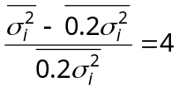 for Belgian securities.

If the average variance of a single security, , in each country equals 50, then 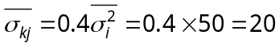 for Italian securities and 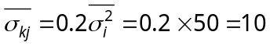 for Belgian securities.

Using the formula shown in the preceding answer to Problem 3 with = 50 and either = 20 for Italy or = 10 for Belgium we have:

Portfolio Size (N securities) Italian Belgian

5 26 18

20 21.5 12

100 20.3 10.4

Chapter 4: Problem 6

The formula for an equally weighted portfolio's variance that appears below Table 4.8 in the text is

where 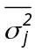 is the average variance across all securities, is the average covariance across all securities, and N is the number of securities. The text below Table 4.8 states that the average variance for the securities in that table was 46.619 and that the average covariance was 7.058. Using the above equation with those two numbers, setting 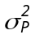 equal to 8, and solving for N gives:

8 = 1/N (46.619 - 7.058) + 7.058

.942N = 39.561

N = 41.997.

Since the portfolio's variance decreases as N increases, holding 42 securities will provide a variance less than 8, so 42 is the minimum number of securities that will provide a portfolio variance less than 8.

